# AQUA-BOT

BACHELOR OF TECHNOLOGY in

ELECTRONICS AND COMMUNICATION ENGINEERING.

G Yashwanth Kumar(211EC112)

**DEPARTMENT OF ELECTRONICS AND COMMUNICATION ENGINEERING, NATIONAL INSTITUTE OF TECHNOLOGY KARNATAKA,**

**SURATHKAL, MANGALORE –575025.**

**March, 2023.**

# ABSTRACT.

Water is essential for human civilization and the history of plumbing goes to Indus Valley civilization of 4000- 3000 BC. Humans have made many inventions to bring water to their point of use, i.e., bathroom, toilet, kitchen, washing, cloth washing, gardening, livestock, etc. in their home, business, and office buildings; with piping and taps and water storage tanks holding water for a day’s need. Presently, city water in piped supply lines is pumped to the roof-top storage tank using water pumps controlled with an electrical switch. Similar system of pump and switch is employed to pump ground water from bore-well, in places where no piped water supply exists, or there is insufficient supply. Small water storage tanks with a water pump are seen in rural and other places and cities for pumping ground water. Surprisingly in many installations, no device is fitted to automatically switch off the pump when level in the tank reaches full. So, the water pump is left running, leading to overflow causing loss of water and energy.

Roof-top water storage tanks are seen to be overflowing many times in many buildings of rural and urban cities of India with consequent loss of water and energy. The consumer complaint portals are full of complaints of overflow, contaminated water, and no water supply. These are due to deficiencies of the water storage tank installations. An audit of practices and arrangements of the individual storage tank installations in Delhi has exposed the deficiencies in the installations in water level control. The quantum of water loss of an overflowing tank is estimated using theoretical analysis and experimental methods. And by a survey of a colony on overflow, it was found out that 7% of the water supplied was lost; and additionally, 3.84% of the energy supplied was also lost; in one of the two colonies of Delhi. Automatic cut off controller and a smart controller with a capacitive sensor for level and capacitive sensor for flow sensing and microcontroller are suggested. The study has brought to light that 90 billion liters of treated water and 90 billion kW-hr of energy can be saved in a month in India by introducing affordable smart controller and by directing the households to adopt this device in their storage tanks.

# TABLE OF CONTENTS: -

|  |  |  |
| --- | --- | --- |
| Sl. No. | Contents | Page Number |
| 1. | Introduction | 4 |
| 2. | Design | 5 |
| 3. | Implementation | 7 |
| 4. | Results and Discussions | 11 |
| 5. | Conclusions and Future Works | 11 |
| 6. | References | 11 |

***INTRODUCTION: -***

The Objective is a “**AUTOMATIC WATER TANK CONTROLLING SYSTEM**”

I designed a project which automatically turns the pump on and off also showing the residents the percentage of water still left in the tank. Whenever the water level is below 20% the “**Pump**” will automatically turn on based on whether the water is coming from “**Reservoir**” (which is the water input from government or underground). As soon as the water level reaches 100% the pump will automatically turn off saving water wastage.

There is also a “**Tap**” option which will show the usage of water in household as in when the tap is on the water level will decrease. The assumption made here is the rate of flow if water is same in filling and using. The project also shows the “**Percentage**” of water still in the tank.

To make this possible we need a “4-bit binary up-down counter” with four clears and four presets. The counter is connected to a “**JK-Flip flop**” in such a way the “**J and K**” depend on the output of the 4-bit binary up-down. The output of the JK-Flip Flop is connected to the 4-bit binary up-down as “**Mode**” and “**Enable**” making the project a memory in memory.

# DESIGN: -

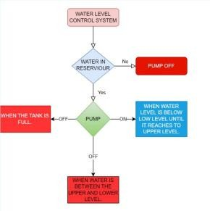***FLOWCHART & STATE DIAGRAM:***

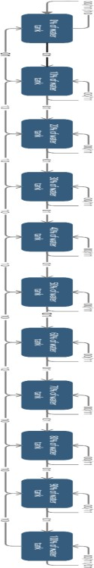

***IMPLEMENTATION: -***

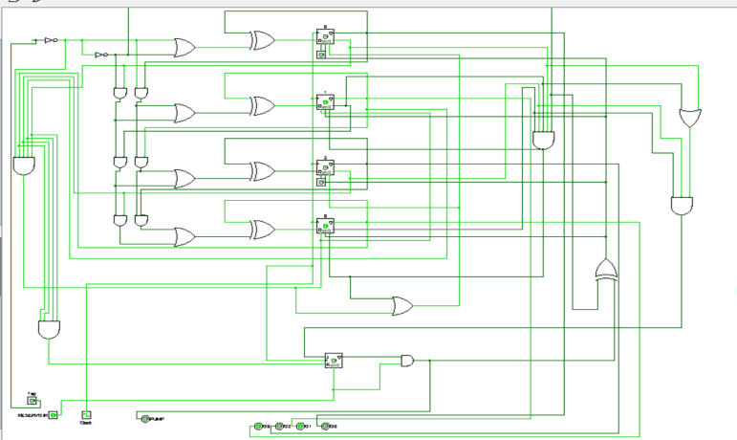***LOGISIM CIRCUIT:***

***VERILOG (Behavioral model):***

module Reservior(r,clk,p,count); input r,clk;

input [3:0] count; output p;

reg p; always@(posedge clk) begin

if(r==1) begin if(count==10) p<=0;

else if(count<=2) p<=1;

else if(count>2&&count!=10) p<=p;

end

else if(r==0) p<=0;

end endmodule

module Tank(T,r,clk,count,C,P); input T,clk,r;

output [3:0]C; output P;

input [3:0] count; reg [3:0]c;

assign C=c; wire p; assign P=p;

Reservior dut(r,clk,p,count); always@(posedge (clk),p,T) begin c=count; if(T==1&&p==0) begin

if(c==0) c=0;

else begin c=c-1; end

else if (T==0 && p==1) begin if(c==10) begin c=c; end

else begin c=c+1; end end

else begin c=c;end endmodule

# TEST BENCH:

module TB; reg clk,r,T; wire P;

reg [3:0] count; wire [3:0]C;

Tank d(T,r,clk,count,C,P); initial

begin clk=1;

forever #5 clk=~clk; end

initial begin

r=0; count=1; T=0; #10;

r=1; #10;

count=5; #10;

count=0; #10;

count=10; #10;

count=8; #10;

T=1; count=6; #10;

count=0; #10;

count=1; #10; r=0; #10;

count=5; #10;

count=10; #10;

$finish; end endmodule

# OUTPUT:

INPUT = (TAP) (RESERVOIR) (WATER ALREADY PRESENT IN THE TANK) OUTPUT = WATER IN THE TANK NOW.

# RESULTS AND DISCUSSIONS: -

Colossal water and energy losses due to overflow are estimated using different techniques that point to the urgent need to implement the intelligent controller. So, using such an automated control system can reduce water wastage due to overhead spillage. Adding capacitance and float sensors into a robust, intelligent controller will remove deficiencies if implemented. In conclusion, a standard controlling mechanism for switching off the water pumps must be implemented on every rooftop water storage tank installation.

There are many variations of the same system with indicators and alarms that can also be implemented. Still, this system might be the most straightforward, cost-efficient, and easy to use.

# CONCLUSION AND FUTURE WORKS: -

The default starting case is when the tank is completely empty and we must give the reservoir input and the tank gets filled until 100%. This is an automated water filling system where level will increase when its below 20% when water is coming from reservoir. This project also has a tap which shows the water usage in the household. Water coming from the govt. Is taken as reservoir. This project is made using binary up-down counter and flip flop. The wastage will be reduced by the automatically by turning the pump off at 100%. This reduces the human work of checking tank and turning motor on and off manually.

There is power wastage in clock, which should be connected to reservoir as a switch. There is plan to add a physical object in the tank to show the water level exactly that is when the machine has an error. Verilog cannot be made in dataflow and gate level as it is too complex.

# REFERENCES: -

1. ADB Asian Development Bank: 2007 Benchmarking and Data Book of Water Utilities in India, 2007, p.3.
2. Consumer complaints DJB:

<https://www.consumercomplaints.in/complaints/delhi-jal-board-delhi-east>delhi-delhi-c416909.html

1. 4 Bit Binary Up-Down counter using D flip flops: <https://www.youtube.com/watch?v=BTYrDs5A0gk&ab_channel=RafeeAmin>
2. DSD Lab Manuals.
3. DSD Notes.